**ToString() to Display Score**

**Objective:** In this lesson students will display an accurate score to the scoreboard.

1. Open the ScoreBoard.cs script
2. Now in the ScoreBoard GameObject we want to access the TextMeshPro module

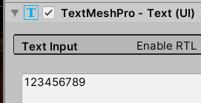

1. In the script lets Import TextMech Pro



1. Lets create an Instance of this TextMeshPro

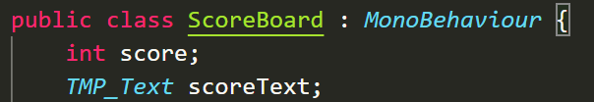

1. Create the Start method

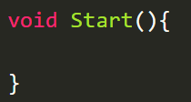

1. Now in the Start method we’re going to use to **scoreText** variable to store our component



1. Now to change the text box in this module we’re going to use the .text method and change it to Start to signify the start of the game

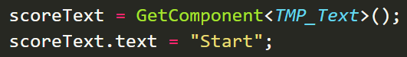

1. Play test the Game
2. In the **IncreaseScore** method lets delete the print statement

**Challenge:**

Now we want to set the score as the Text but the score is an Integer and the text field only accepts strings. We’re going to use the ToString() method to convert it.

**Solution:**

